Rocky Road

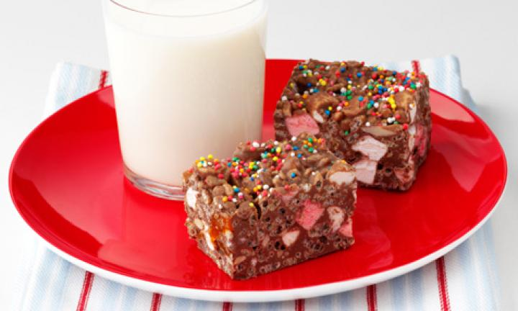

Ingredients
- 4 cups milk chocolate melts
- 80g copha
- 3 cups Kellogg&#039;s Rice Bubbles
- 100g packet mini marshmallows
- ½ cup slivered almonds
- ½ cup finely chopped dried apricots
- Hundred and thousands to decorate

method
- Grease a 20cm square cake pan. Line base and sides with baking paper.
- Stir chocolate melts and copha in a large bowl, over a pan of simmering water, until smooth. Remove from heat.
- Stir in remaining ingredients; mix until well combined.
- Spread mixture into prepared pan.
- Sprinkle over hundreds and thousands.
- Refrigerate until firm.
- Cut into squares.
- Store in an airtight container in the refrigerator.

As found from http://www.kidspot.com.au/kitchen/recipes/super-easy-rocky-road-1652?ref=collection_view%2Cchristmas-recipes-for-kids

